KPI system user Guide
SIMAH

7/4/2022

Osama Salameh
KPI system user Guide
SIMAH

Introduction
KPI system, is built to help PMOs to monitor there department’s performance and to make sure they are on the track to achieve their main goals, etc…

- KPI login
  - Open your favorite web browser
  - Go to http://kpi.ksacb.com.sa
  - Enter your User name and password
  - Click login
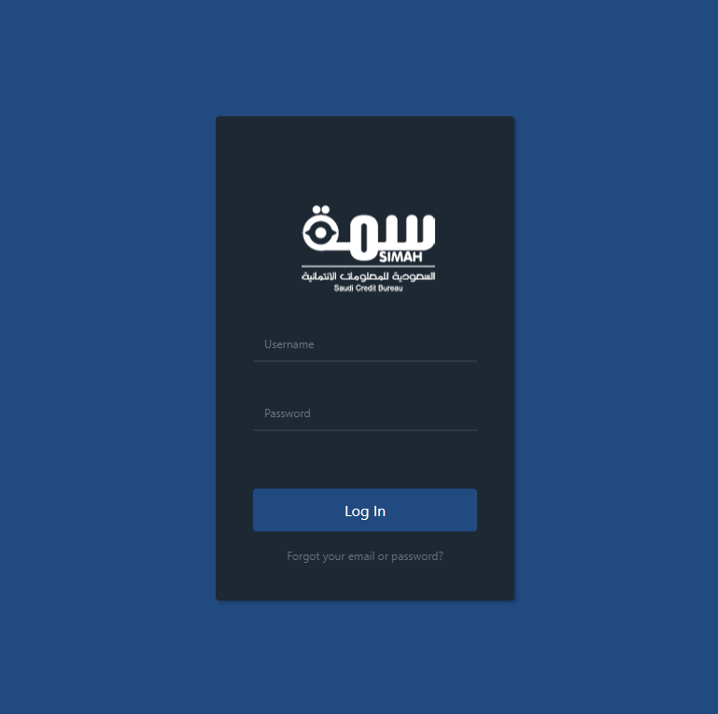

- Main page
On this page, you are able to navigate through all the system components and pages, It's the very first page the system take you after logging.
P.S. Navigation tiles could be changed based on your permissions.
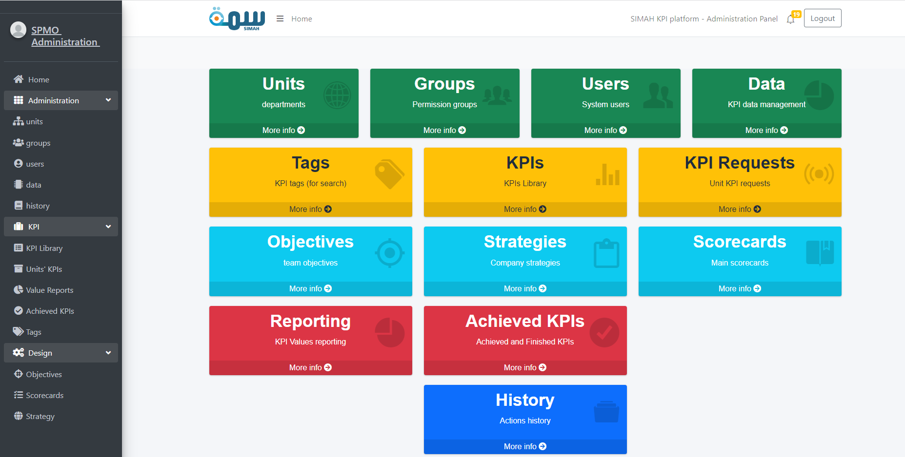

- Administration section – Units
  - On this page the admin (SPMO), is able to manage and explore all his organization’s departments.
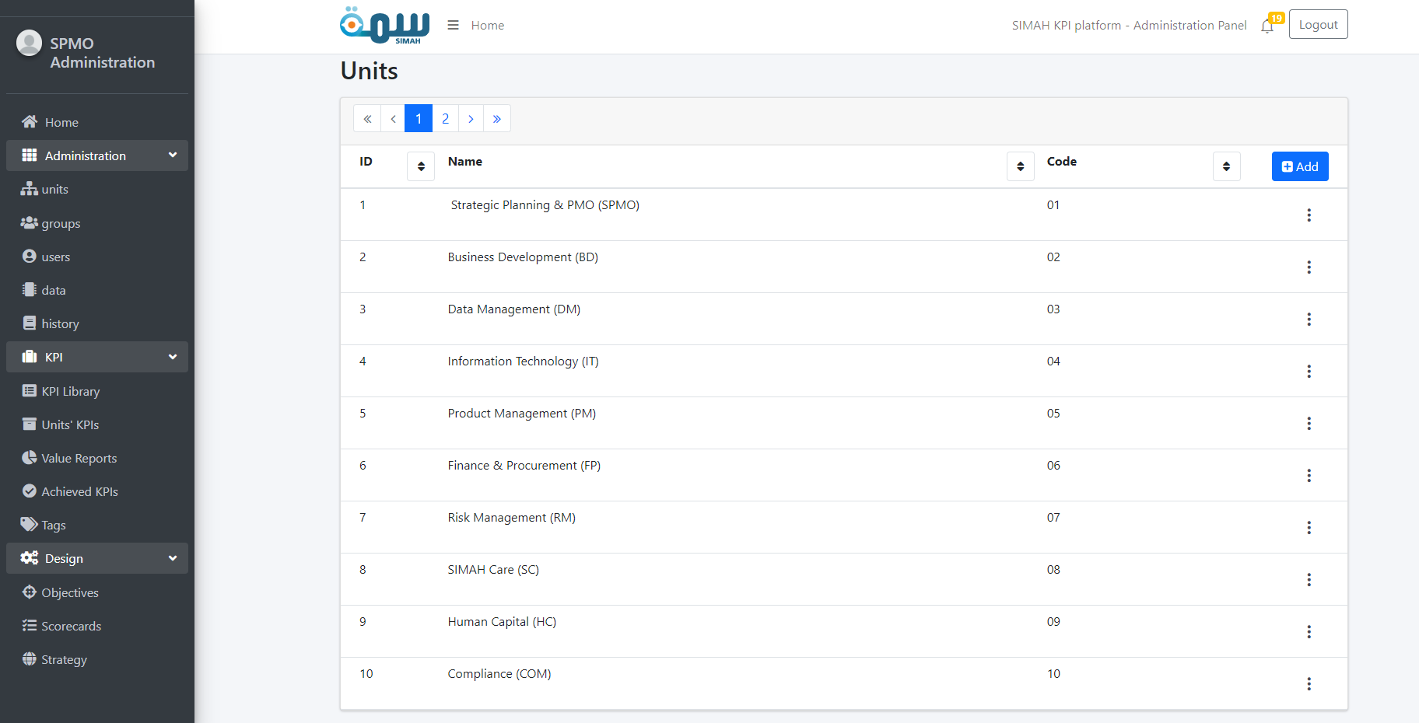
To be able to take actions on each department, he should press on the 3 dots button, like follows
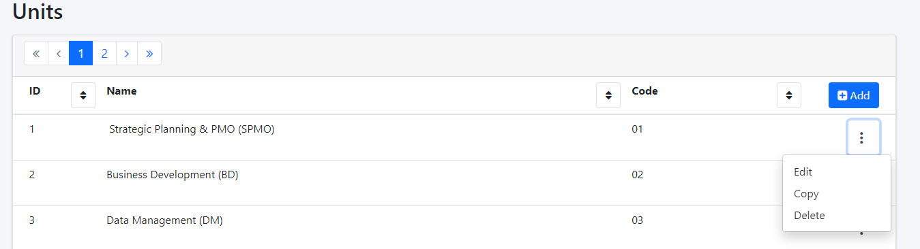

  - Edit action:
Click “save changes” after filling all the required data to save your inputs.

P.S. all required fields are marked with little red star (*).
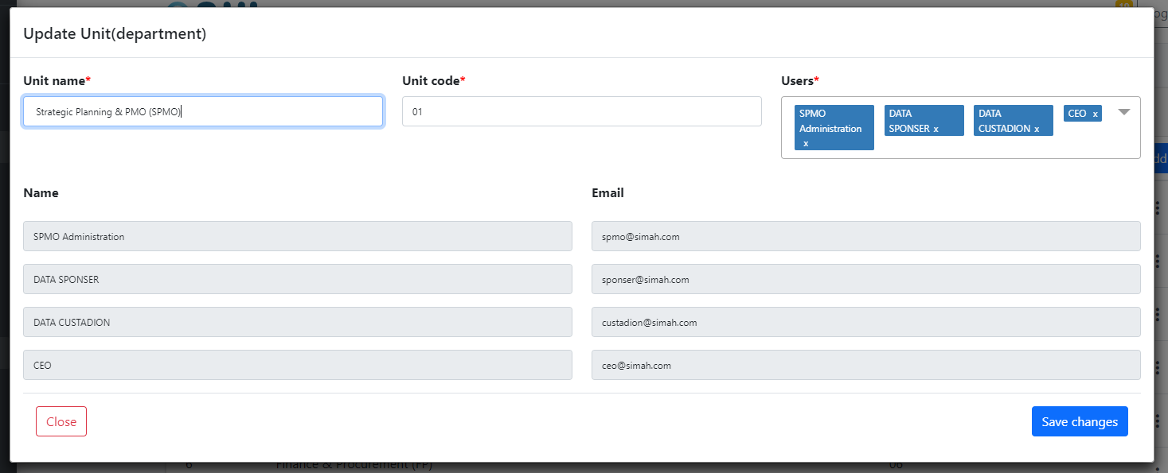
  - Copy action:
Click “save changes” after filling all the required data to save your inputs.

P.S. copy action is just like editing, the different here is that your inputs will be saved as new object (data), into the system.
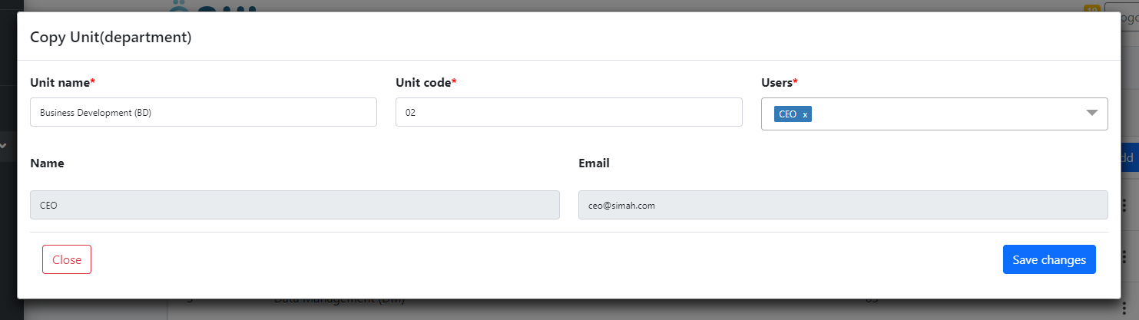
  - Add action:
Simply fill all required fields, and click “save changes”, and your data will be added to the system.
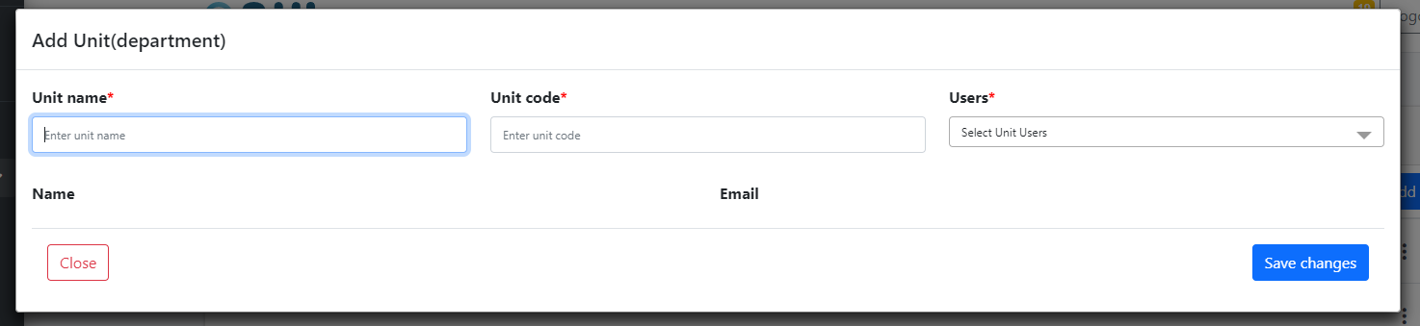
- Administration section – Users management
  - Users Management list: On this page the admin (SPMO), is able to manage and view all the users.
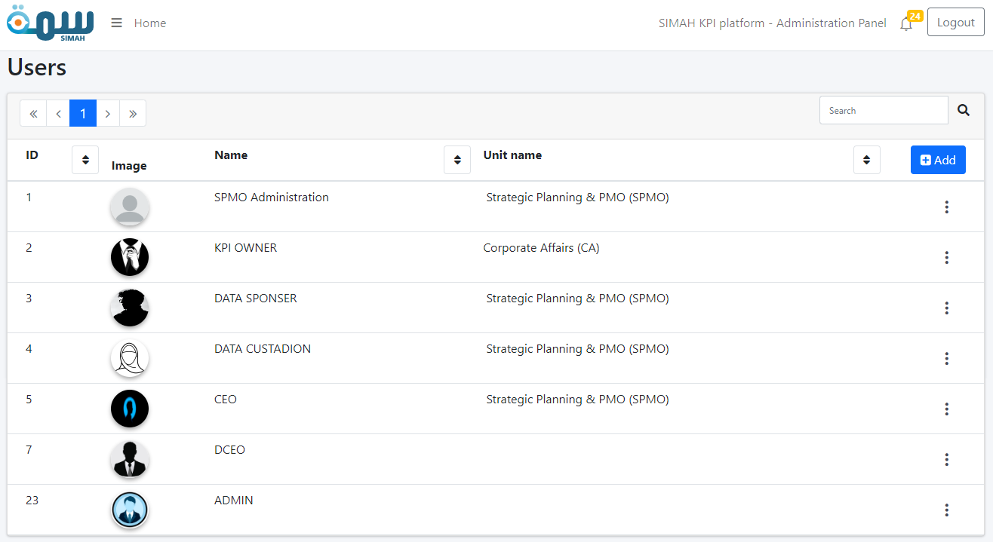
  - Edit action: here the user can edit the main information related to system users.
P.S. Profile picture is uploaded via “Upload” button separately from “Save changes”
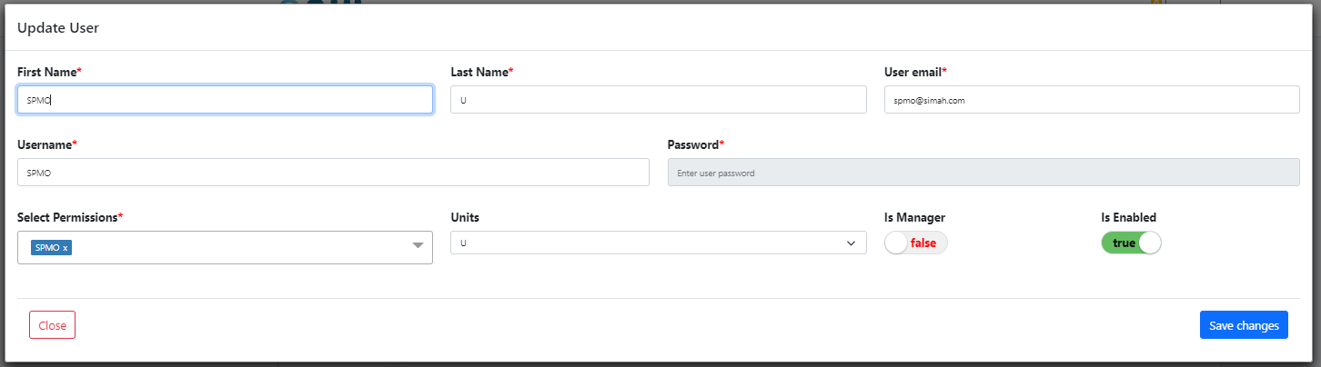

  - Update Image action: on this dialogue the admin is able to update the profile picture for each user, by just clicking on the User image within the table.
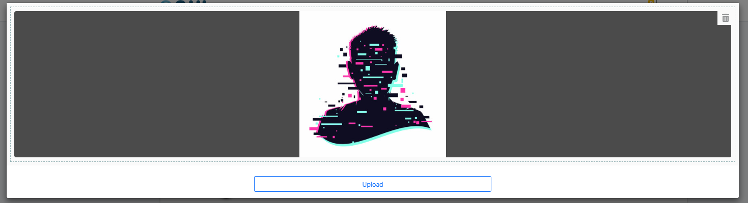
  - Add action: Simply fill all required fields, and click “save changes”, and your data will be added to the system.
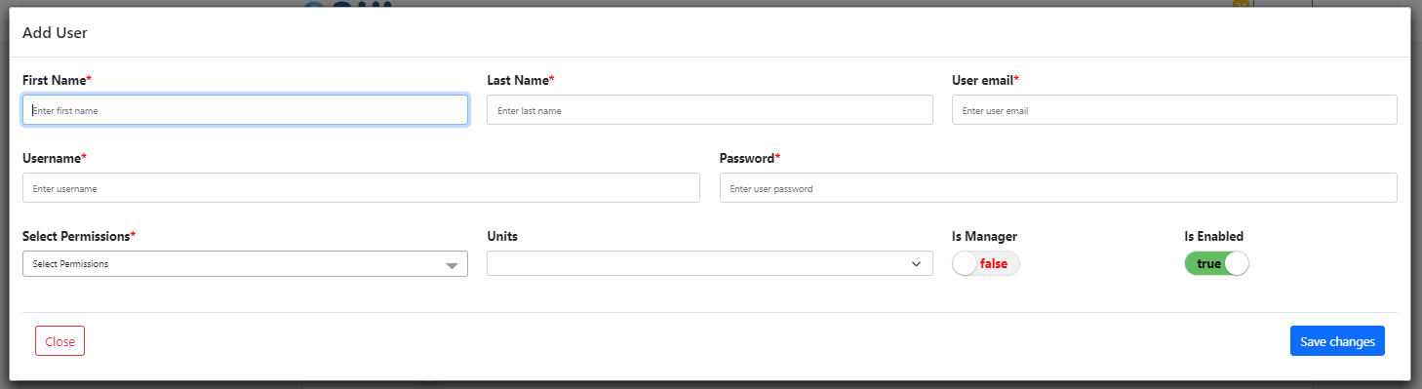
- Administration section – Data
  - Data Management list: On this page the admin (SPMO), is able to manage and explore all the data that would be attached to KPIs later on.
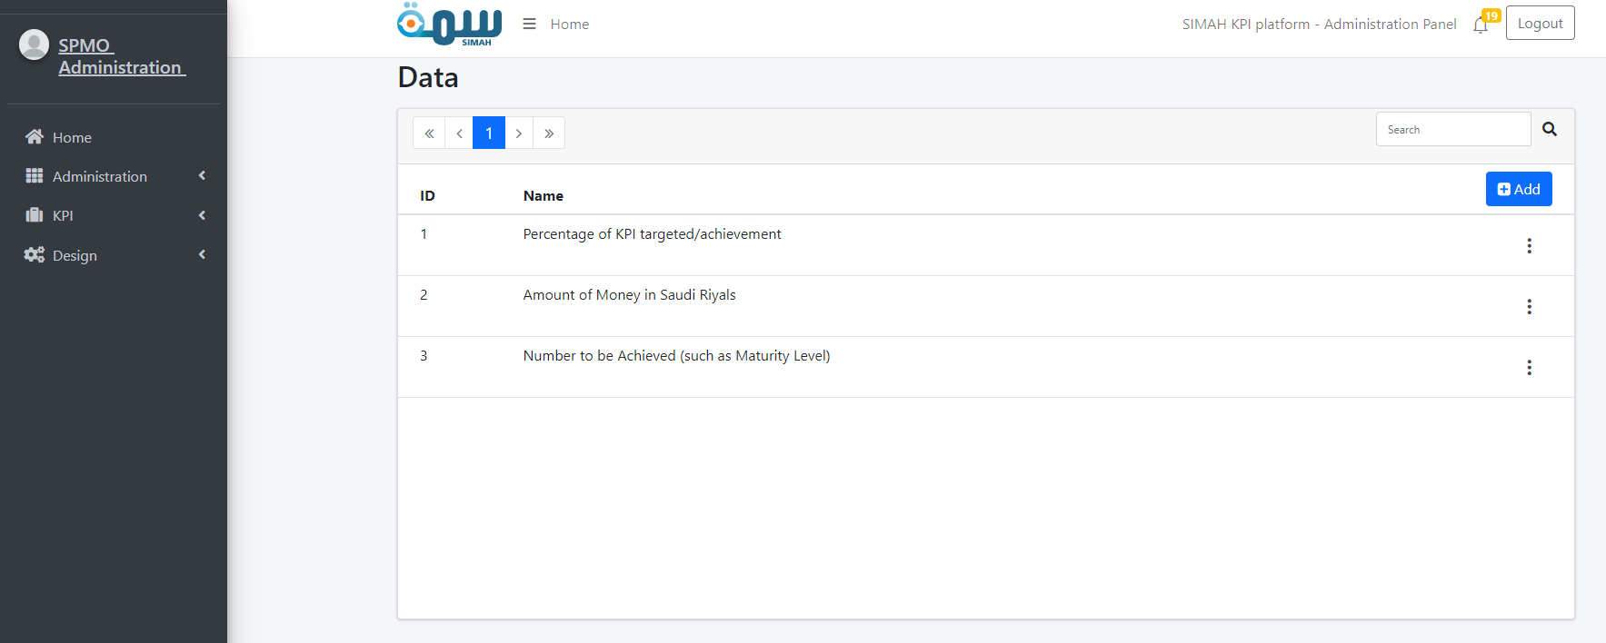
  - Edit action:
Click “save changes” after filling all the required data to save your inputs.

P.S. all required fields are marked with little red star (*).
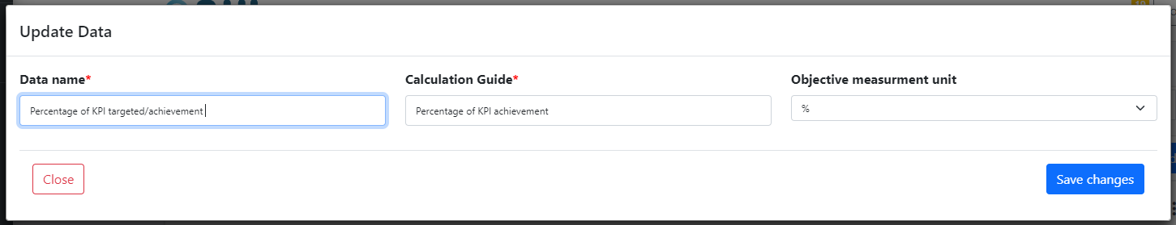

  - Copy action:
Click “save changes” after filling all the required data to save your inputs.

P.S. copy action is just like editing, the different here is that your inputs will be saved as new object (data), into the system.
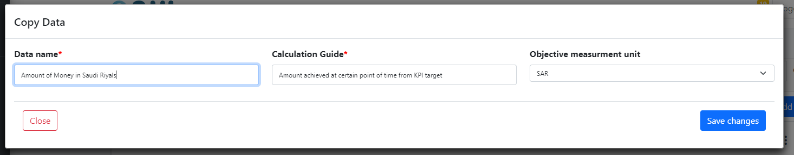
  - Add action:
Simply fill all required fields, and click “save changes”, and your data will be added to the system.
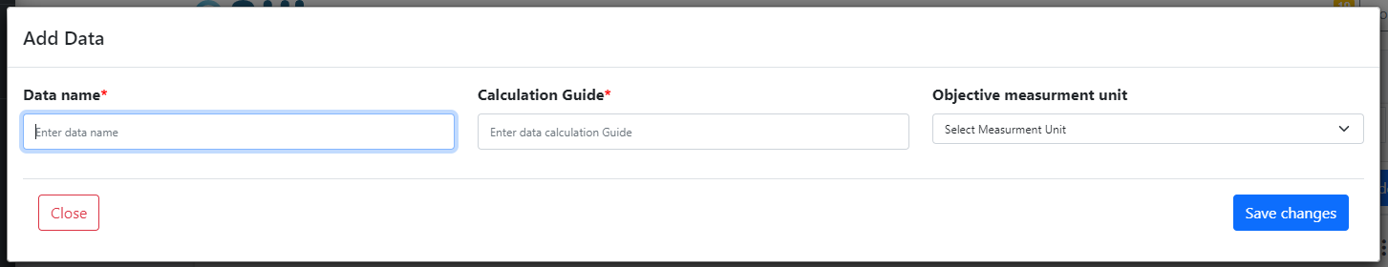

- Administration section – History (Audit Trail)
  - History list: on this page the admin (SPMO), can explore the latest activities on the system, taken by whom and which activity exactly (Add, update, delete).
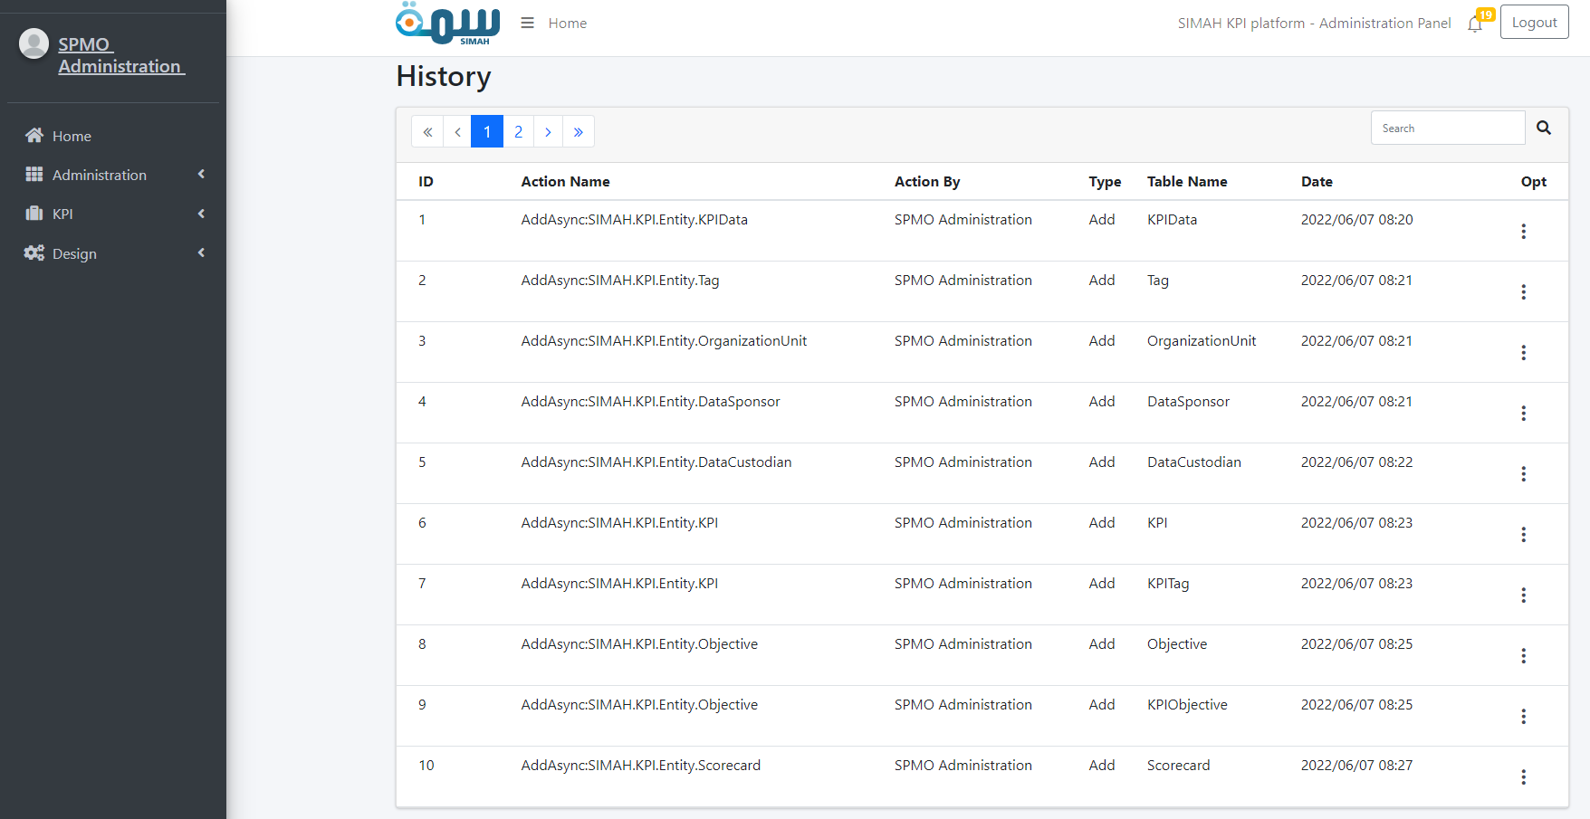
  - View action:
Here the user is able to view the action in details, the exact object affected by the action.
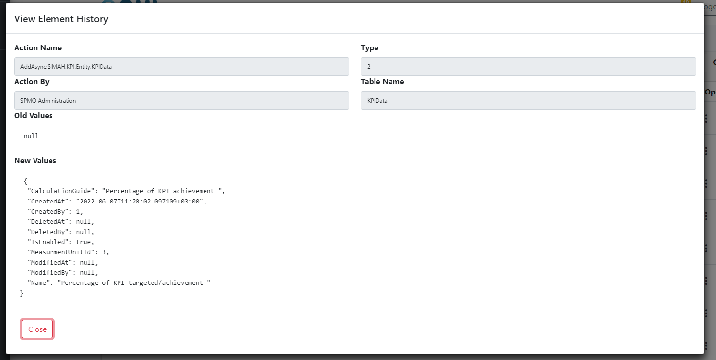

- KPI section – KPI Tags
  - Tags Management list: On this page the admin (SPMO), is able to manage and explore all the data that would be attached to KPIs later on.

P.S. Tags are attached to KPIs, to help searching on KPIs, this section will be explained later on.
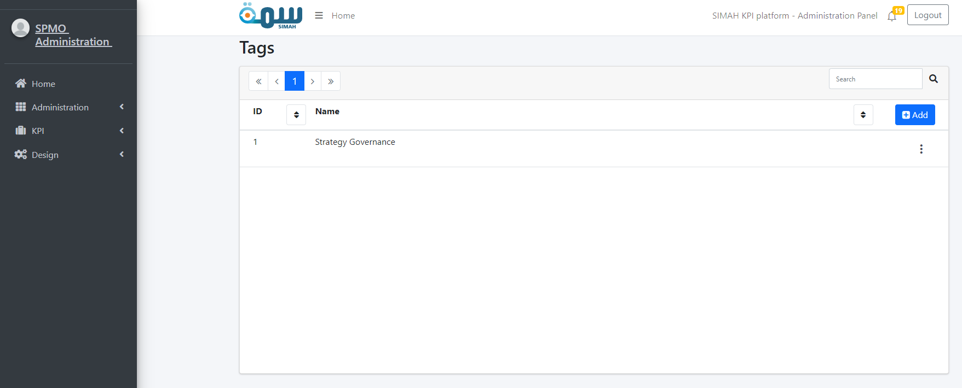
  - Edit action:
Click “save changes” after filling all the required data to save your inputs.

P.S. all required fields are marked with little red star (*).
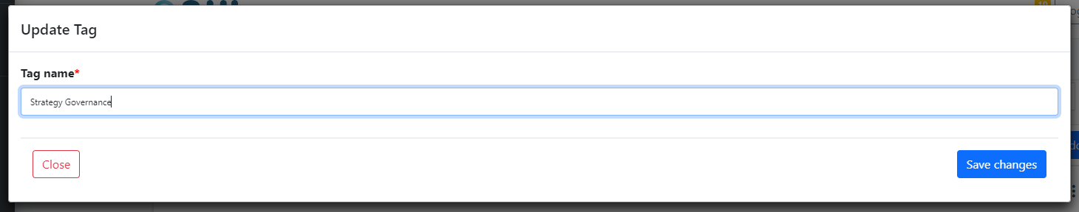
  - Add action:
Simply fill all required fields, and click “save changes”, and your data will be added to the system.
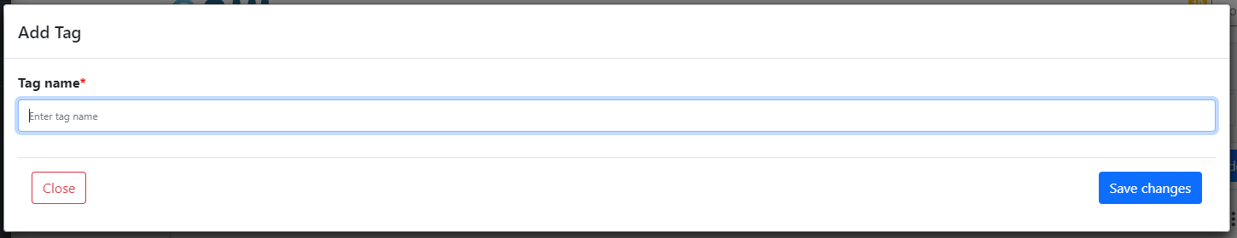

- KPI section – KPI library
  - KPI library Management list: On this page the admin (SPMO), is able to manage and view all the KPIs that would be attached to Departments (Unit KPIs) later on.
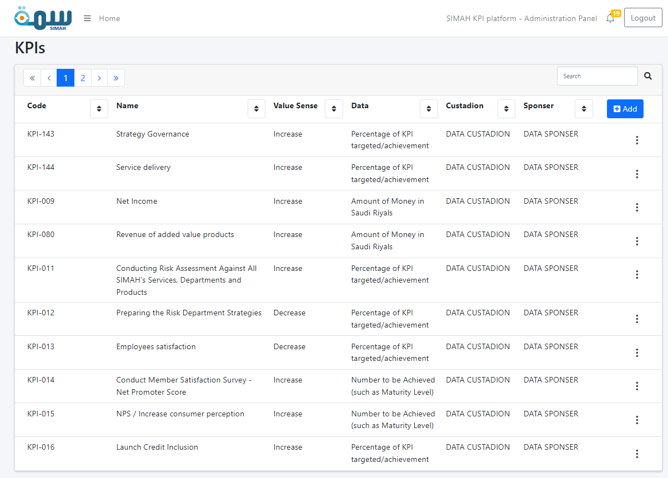
  - Edit action:
Click “save changes” after filling all required fields to save your inputs.
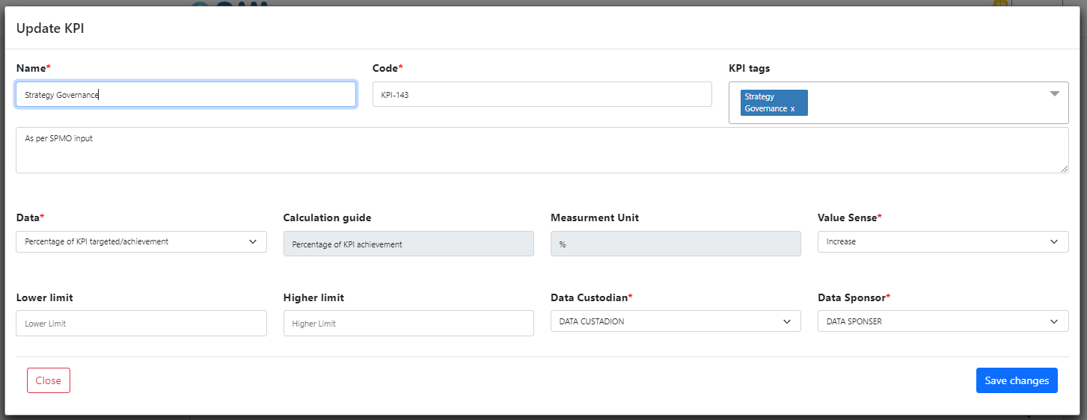
  - Copy action:
Click “save changes” after filling all the required data to save your inputs.

P.S. copy action is just like editing, the different here is that your inputs will be saved as new object (data), into the system.
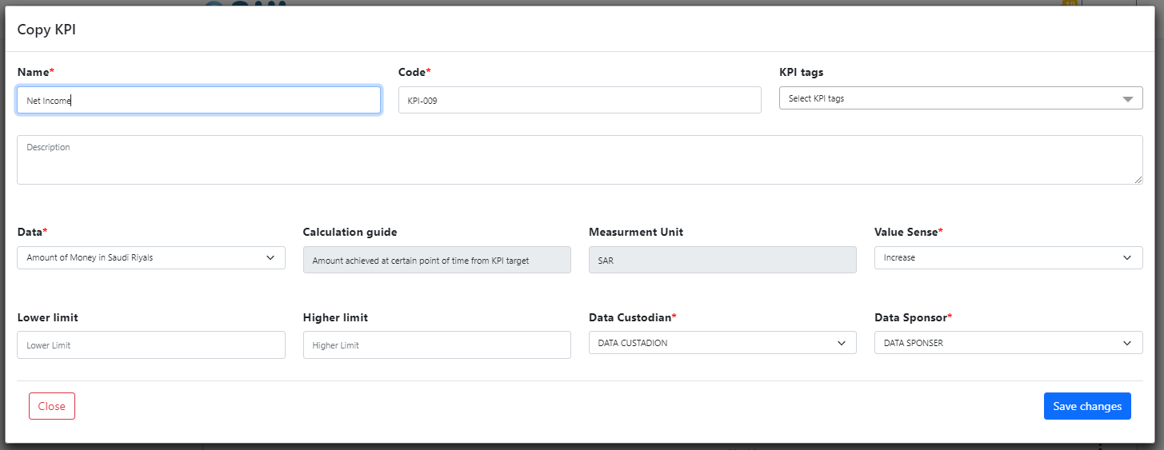
  - Add action:
Simply fill all required fields, and click “save changes”, and your data will be added to the system.
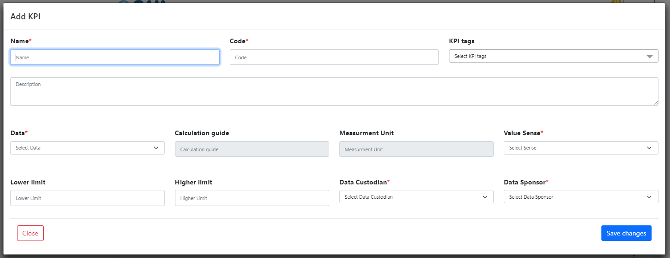

- KPI section – Unit KPIs requests
  - KPI Requests Management list: On this page the admin (SPMO), is able to manage and View all the Units KPI requests, where he should be able to start new request or view an older one, also the (KPI_OWNER) can respond to any request to his department, (CEO) can view and keep tracking the status of each request.
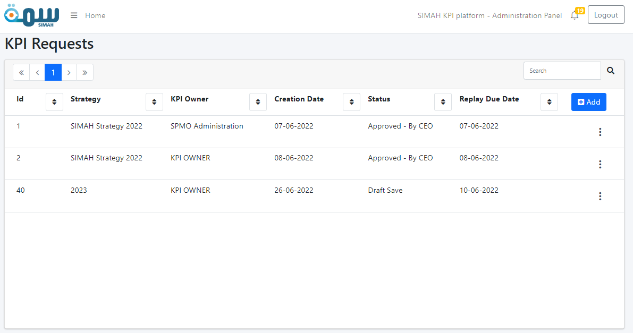
  - View action:
A predefined “unit KPI request” can be viewed by (SPMO, CEO, and KPI_OWNER), containing 3 parts.

B.1 Main information: Only (SPMO) is able to fill these information, and it filled only once at the start of the request (Add action).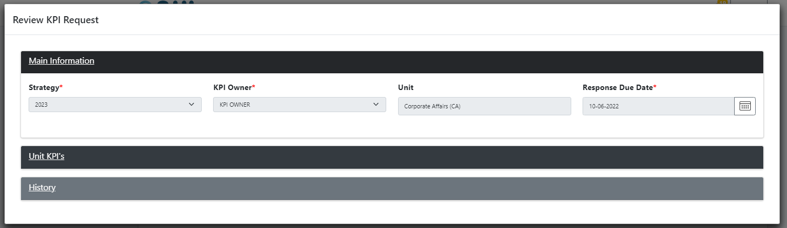

B.2 Unit KPI’s: Only (KPI_OWNER) is allowed to select the KPIs and fill all required fields.
P.S. these KPIs are part of the KPI Library.
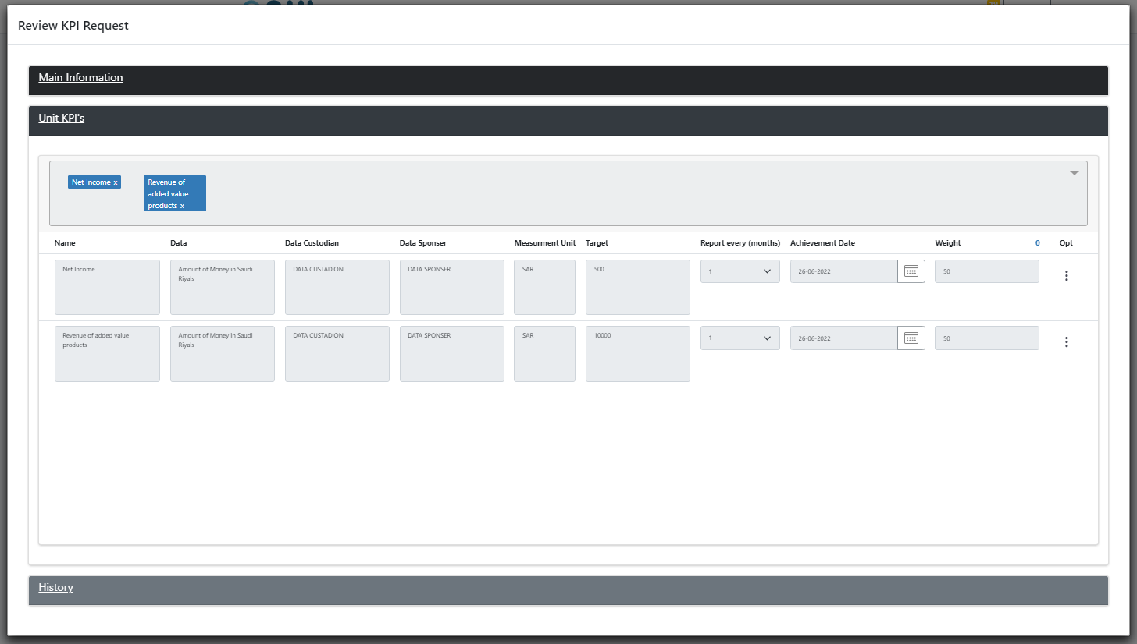
B.3 History: (SPMO, CEO, KPI_OWNER) all are allowed to view this part, where its auto generated from the system to keep tracking the old statuses of the request:
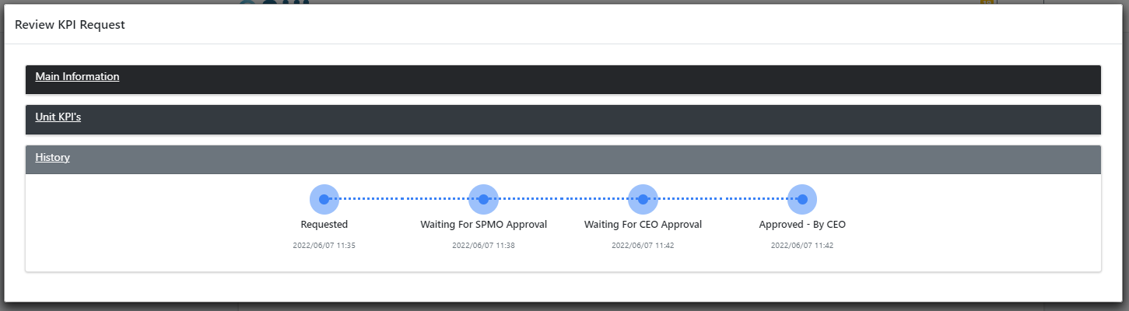

  - Add action:
Simply fill all required fields, and click “save changes”, and your data will be added to the system.
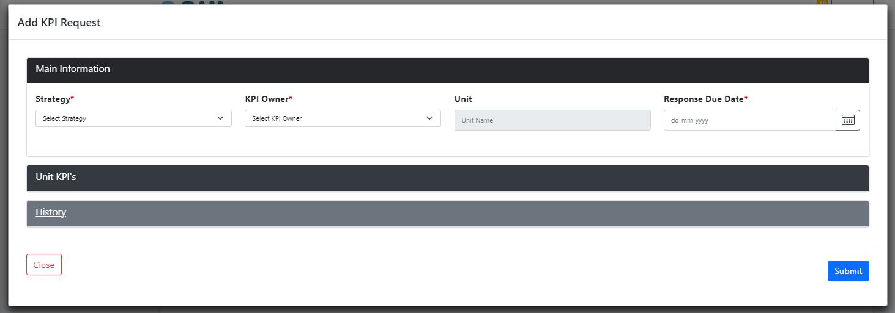

- KPI section – Unit KPI reporting
  - KPI reporting list: On this page the (KPI_OWNER) can view and manage his unit KPIs values (that would be reported later on via CUSTODIAN).
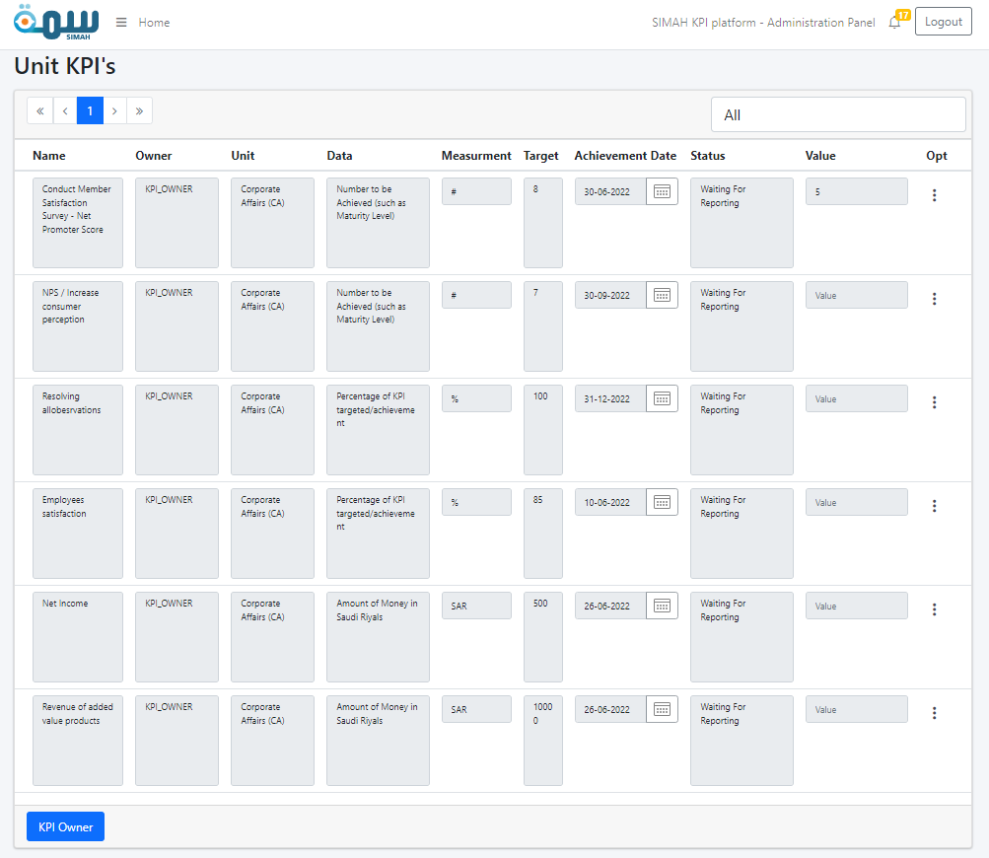

  - Approve action:
By clicking “Approve”, the user is approving the values, which entered via (CUSTODIAN).
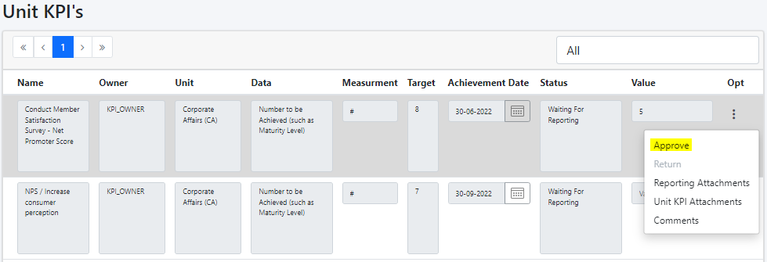
  - Report action:
By clicking on “Report”, the CUSTADION user is reporting the current value of the KPI to the SPONSER to take his action.

P.S. only CUSTODIAN user is allowed to take this action
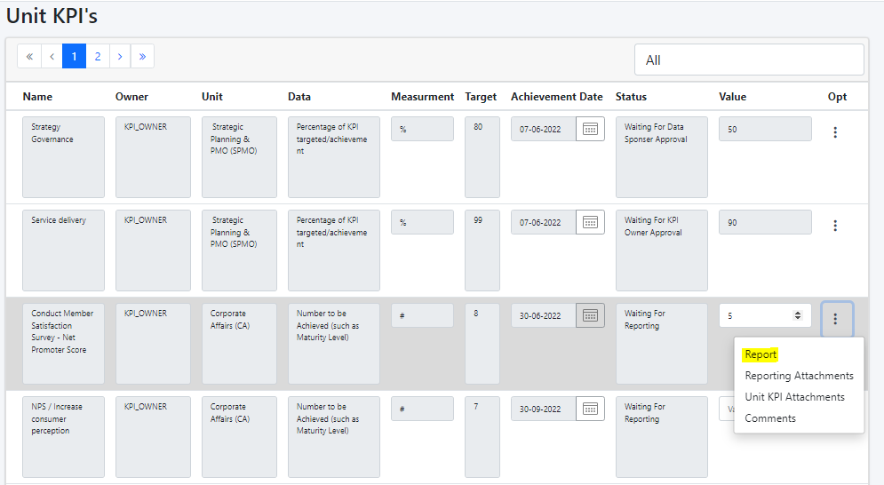

  - Achieve action:
By clicking “Achieve” the user is making the status of the unit KPI as achieved and finished, so there is no need to report it anymore since the Department already met the expectations for this particular KPI.

P.S. only SPONSER user is allowed to take this action
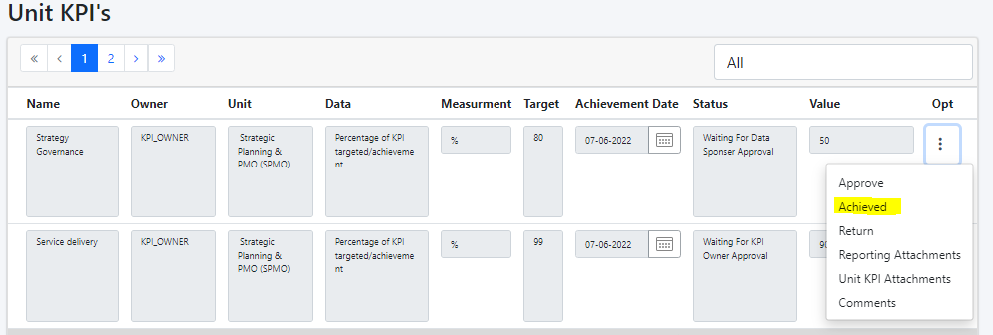
  - Return action:
By clicking “Return” the user is rejecting the values, which entered via (CUSTODIAN).
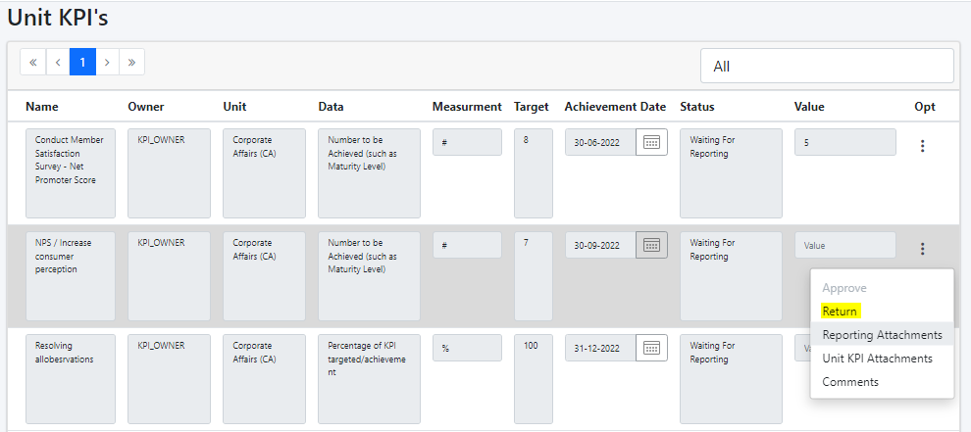
P.S. Other actions will be mentioned later on in Common section.

- KPI section – Achieved KPIs
  - Achieved KPIs list: On this page the user (KPI_OWNER or CUSTODIAN), is able to view all the achieved KPIs.
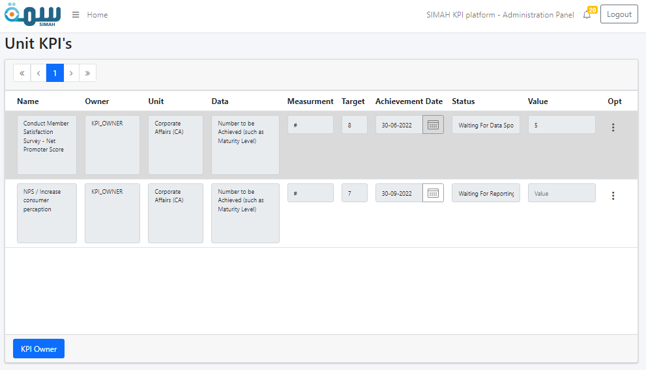
P.S. all actions are considered as common actions, we will explain them later on.

- Design section – Objectives
  - Objectives Management list: On this page the admin (SPMO), is able to manage and view all the Objectives that would be attached to KPIs later on, where each KPI has a single objective.

P.S. objectives would be attached to scorecards later on.
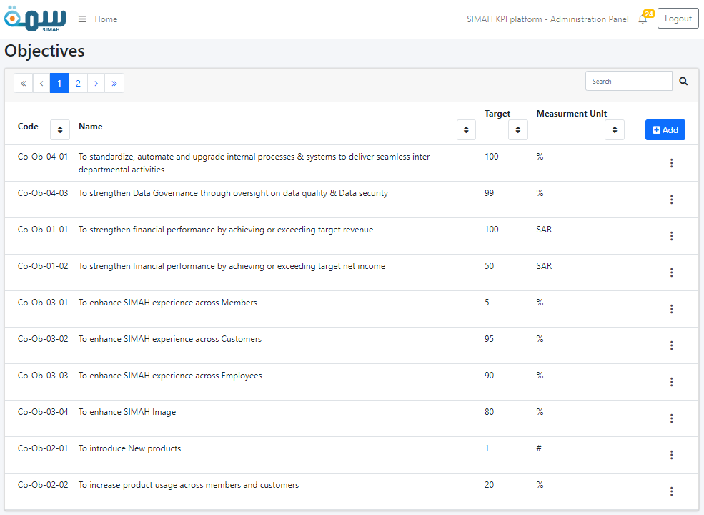

  - Edit action:
Click “save changes” after filling all the required data to save your inputs.
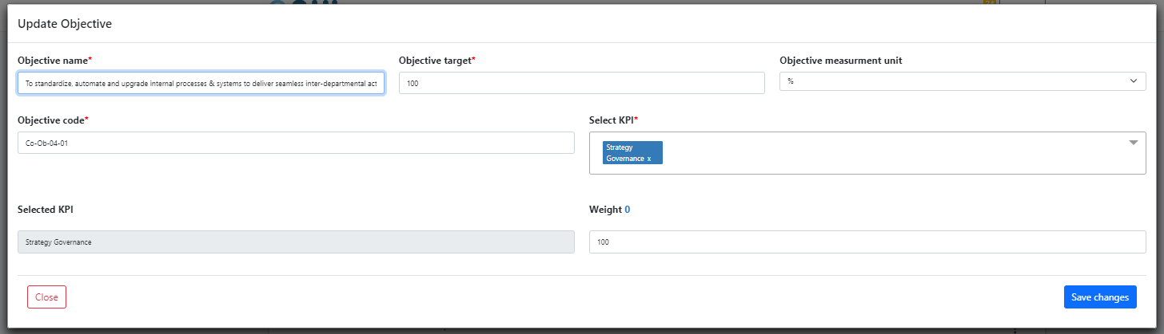
  - Copy action:
Click “save changes” after filling all the required data to save your inputs.
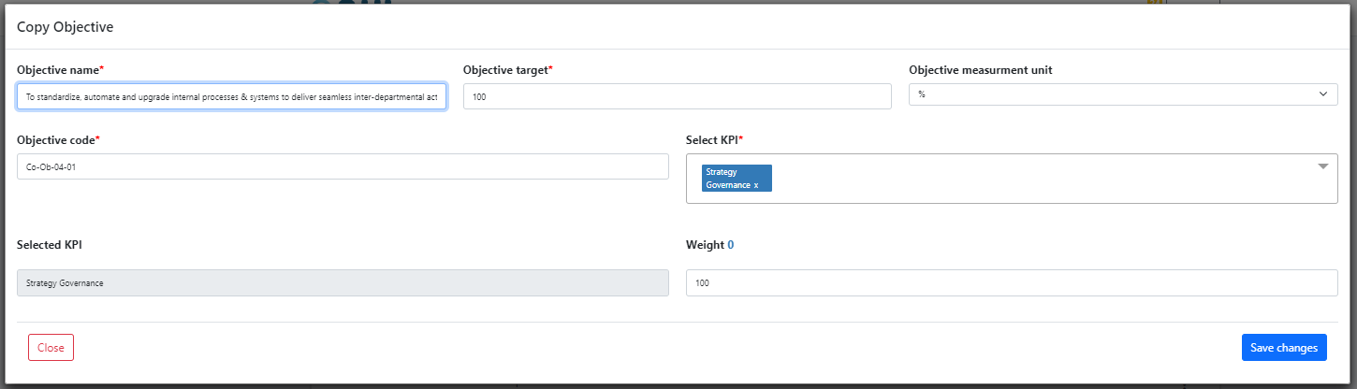
  - Add action:
Simply fill all required fields, and click “save changes”, and your data will be added to the system.

P.S. each objective should be attached at least to one KPI, and the collective weight of selected KPIs should be exactly 100.
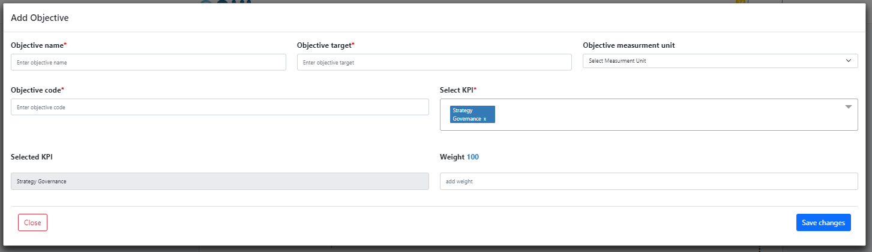

- Design section – Scorecards
  - Scorecards Management list: On this page the admin (SPMO), is able to manage and view all the Scorecards that would be attached to objectives later on.
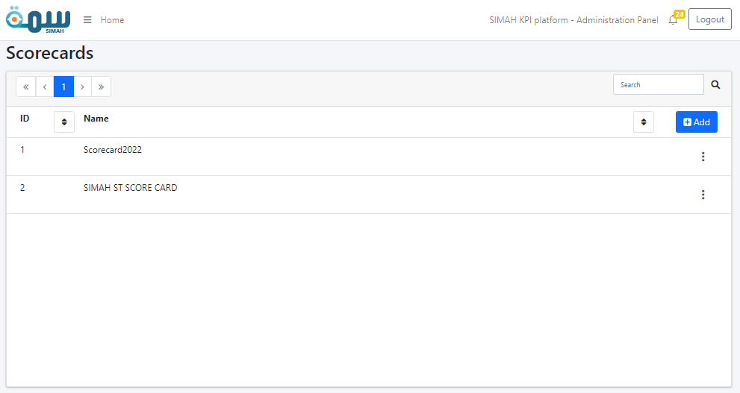
  - Edit action:
Click “save changes” after filling all the required data to save your inputs.
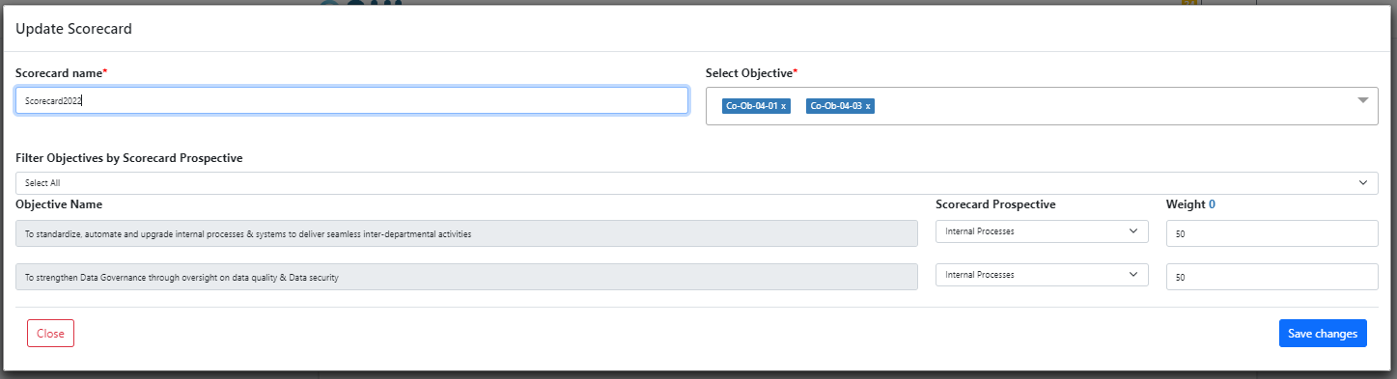

  - Copy action:
Click “save changes” after filling all the required data to save your inputs.
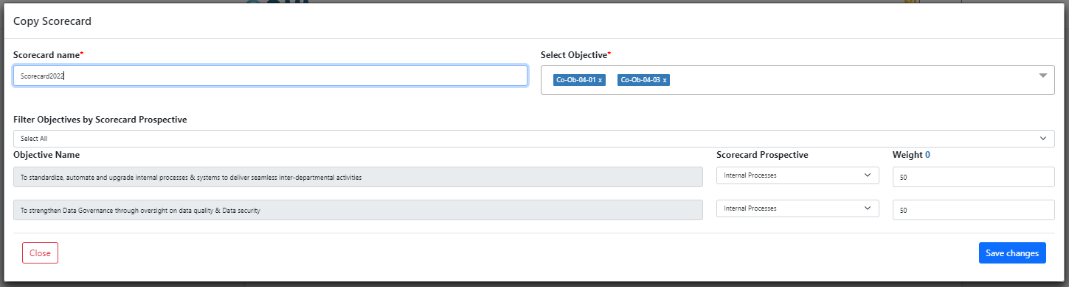
  - Add action:
Simply fill all required fields, and click “save changes”, and your data will be added to the system.

P.S. each scorecard should be attached at least to one objective, and the collective weight of selected objectives should be exactly 100.
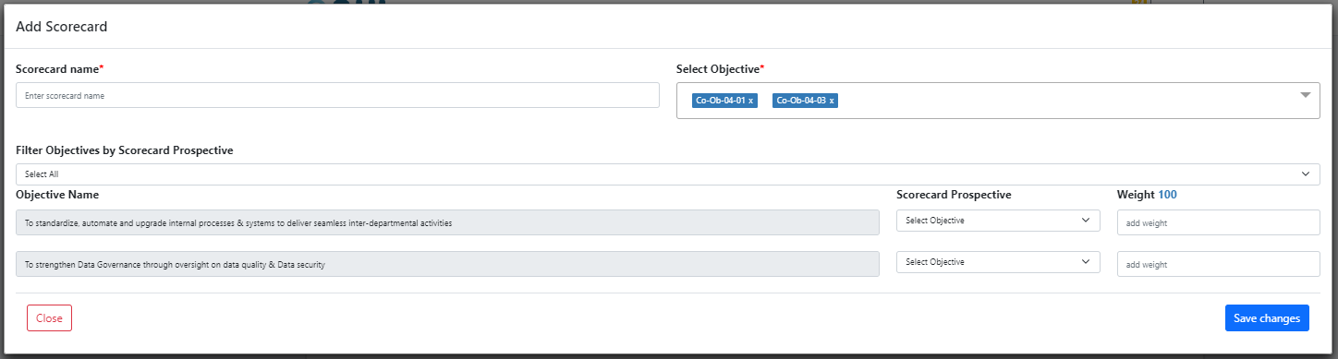

- Design section – Strategies
  - Strategies Management list: On this page the admin (SPMO), is able to manage and explore all the Strategies that would be attached to Scorecards later on.
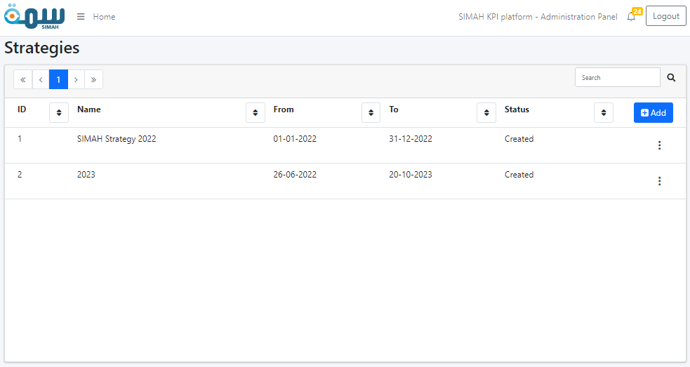
  - Edit action:
Click “save changes” after filling all the required data to save your inputs.
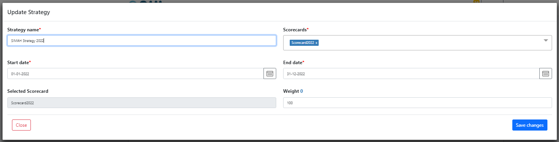

  - Copy action:
Click “save changes” after filling all the required data to save your inputs.
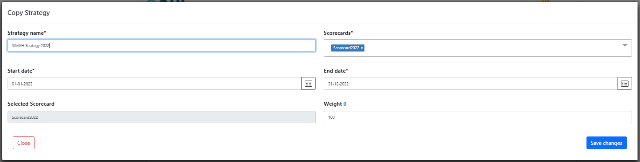
  - Add action:
Simply fill all required fields, and click “save changes”, and your data will be added to the system.

P.S. each strategy should be attached at least to one scorecard, and the collective weight of selected scorecards should be exactly 100.
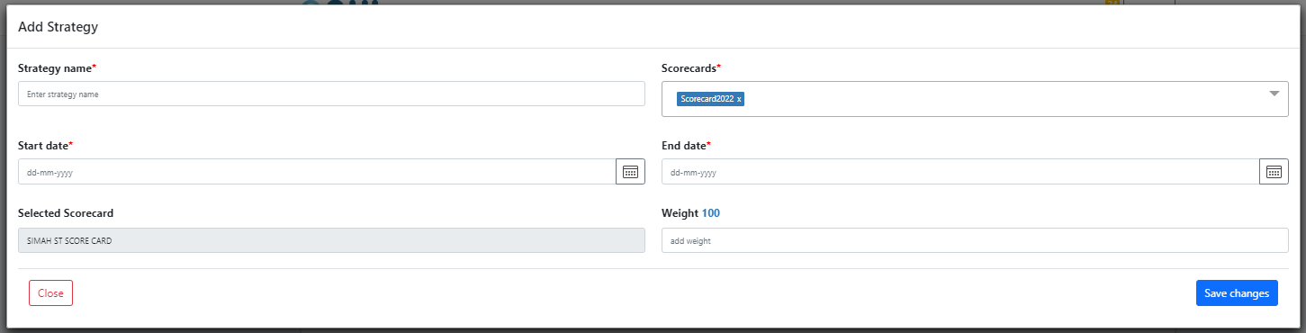
- Notification section
  - The notification window can be viewed, by clicking on the notification bell icon. Where user can view latest notifications, and from there navigate to all notifications.
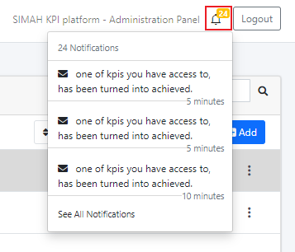
  - Notifications list:
Here the user can view all notifications he have, and chose to view or dismiss.

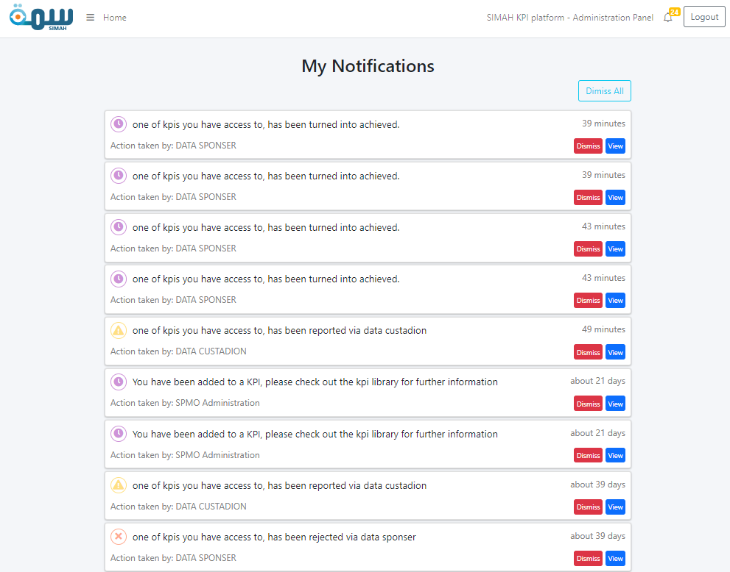
  - View action:
Navigates the user to the exact page of the item notified about.

  - Dismiss action:
Remove the item from the Notifications List.

- Common modals
  - Delete action: Whenever the user tries to delete an item, the system will make sure that this is not mistake, because this action can’t be undone.
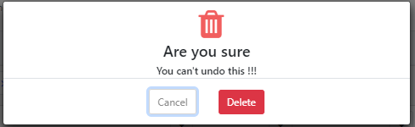
  - Comments action:
All allowed users to this Discussion board, can add a comment to start a conversation, it can be found on each Unit KPI.
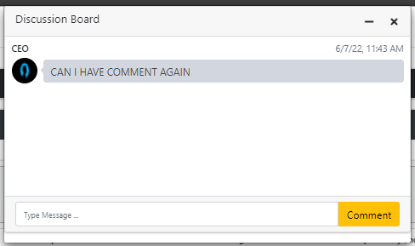
  - Attachments action:
The user can upload/download files through the system.
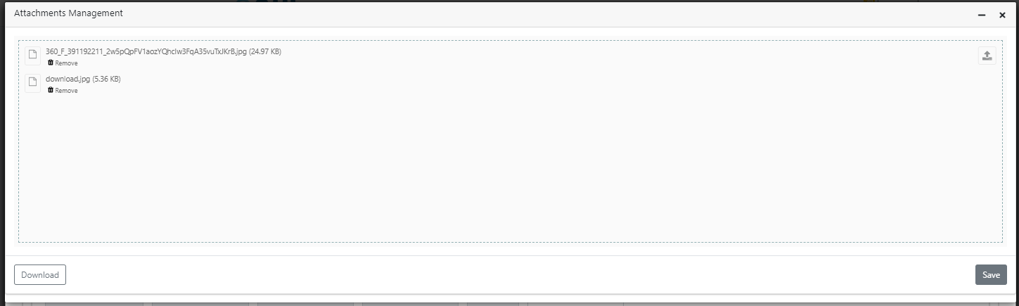
  - Search and navigation bar – tables: this bar is at the top of each table within the system, and used to search for the table content alongside the navigation buttons.
- Personal Information section
By clicking on the username, the user navigated to the profile management page, where it’s divided into 3 parts.
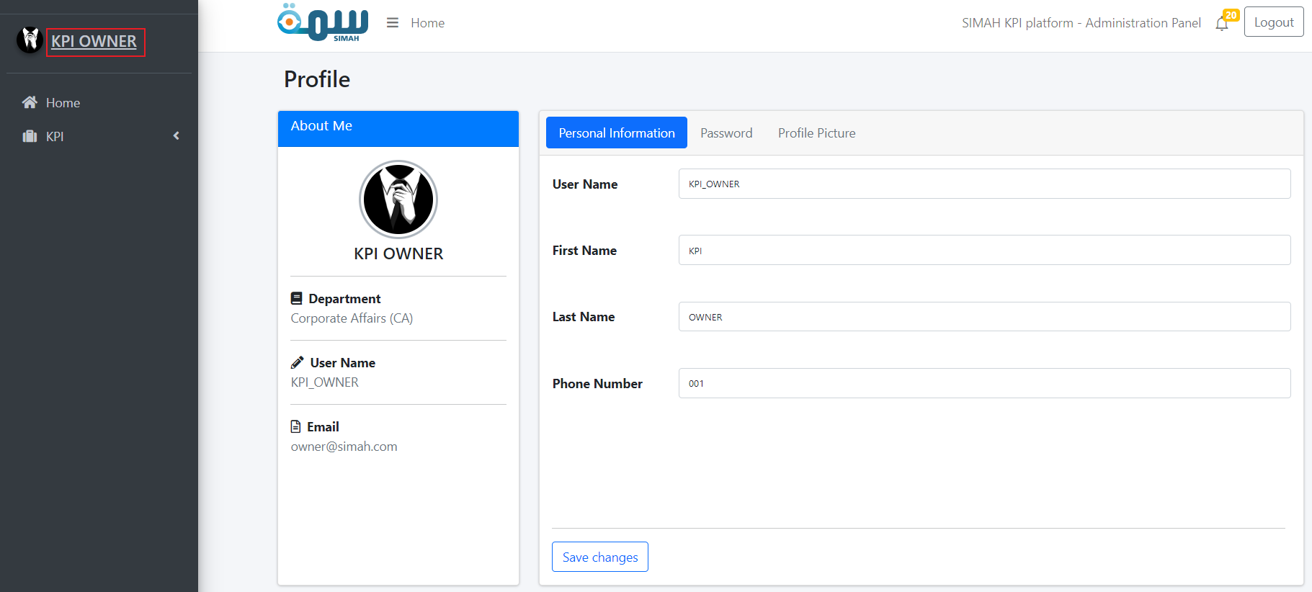
  - Personal information:
The basic information that can be edited.
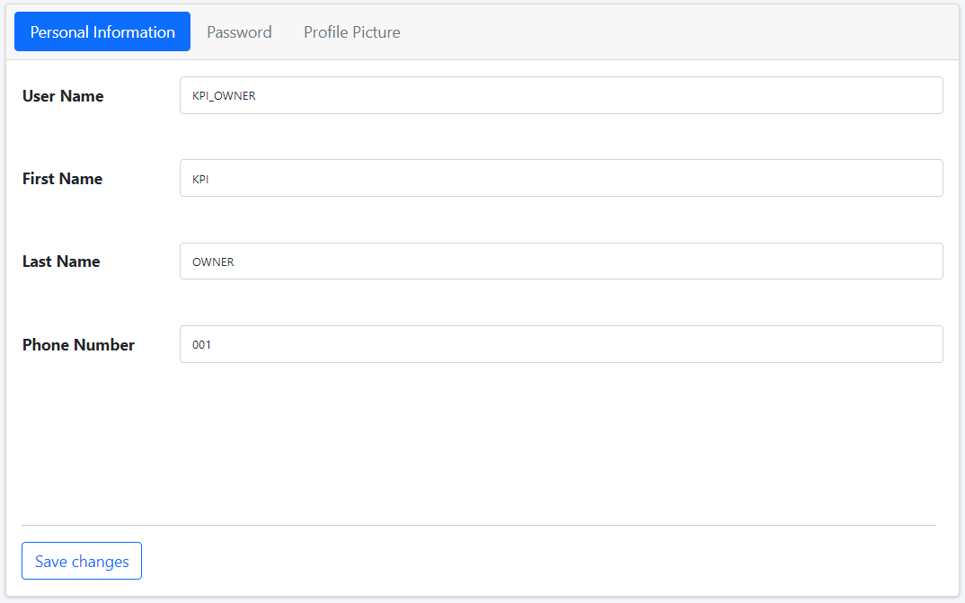

  - Password:
A simple way to change password, without the need for reset password.
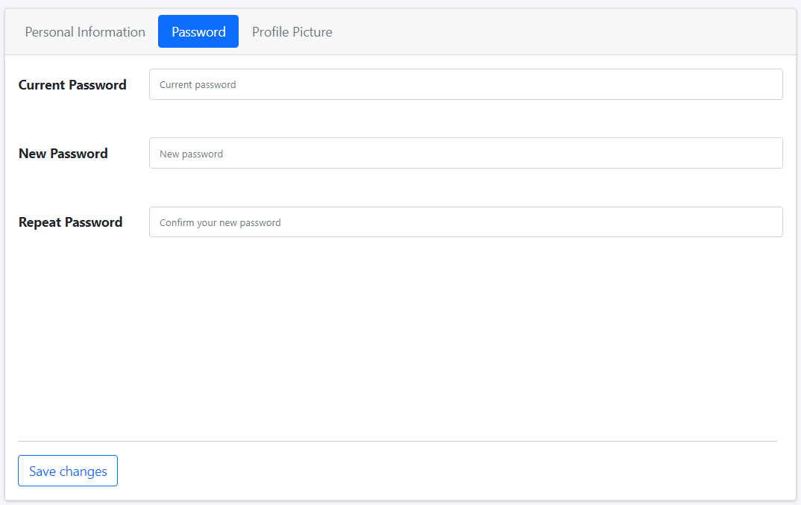
  - Profile picture:
Simply fill all required fields, and click “save changes”, and your data will be added to the system.
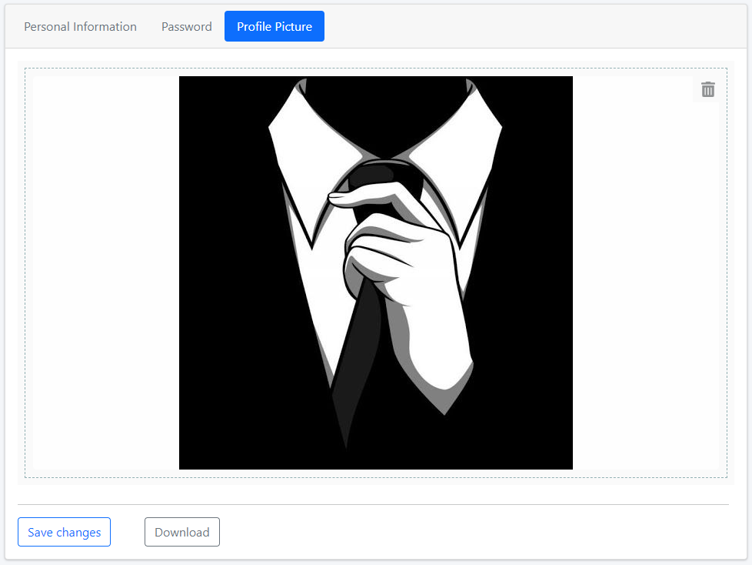

P.S. When saving the Personal or updating the password, the system will log out automatically, asking the user to log in again to have the data affected.
